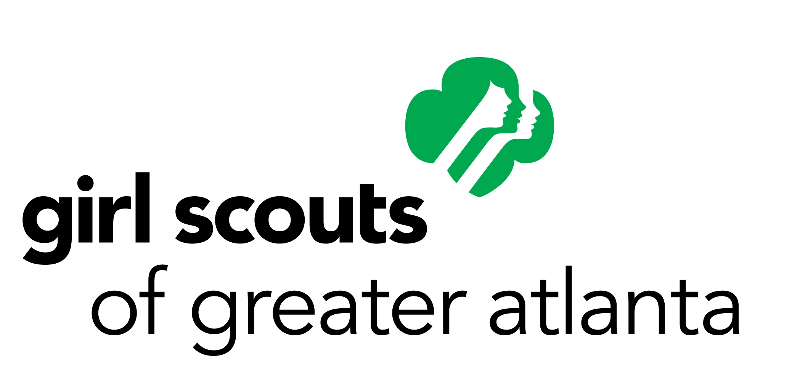
Girl Scouts of Greater Atlanta (GSGATL)
Job Description

Job Title: | Hispanic Engagement Specialist
Reports To: | Senior Director of Membership Recruitment
Status: | Exempt under FLSA, full time
Salary | $35-38K
Location: | Mableton, GA
Last Updated: | August 2015

JOB SUMMARY
The Hispanic Engagement Specialist is the initial contact and primary support to girls, parents and adult volunteers in identified Hispanic communities within the Girl Scouts of Greater Atlanta Council. This Specialist is responsible for executing the strategy to achieve girl and adult volunteer membership goals, and assisting with educating adults on the Girl Scout program.

DUTIES AND RESPONSIBILITIES
- Creates and implements optimal recruitment strategies for girl and adult membership growth within identified Hispanic communities by researching market data, membership trends and other pertinent information in partnership with Senior Director of Membership Recruitment
- Execute a written plan for assigned areas to meet Council goals and objectives related to training, support and retention of Hispanic girls and adults
- Recruit and train Spanish-speaking Program Facilitators
- Assist in the process of volunteer role planning and development in identified Hispanic communities
- Support Council marketing initiatives to identified Hispanic communities by consulting with marketing team to ensure culturally appropriate communication of activities and programs
- Partners with Outreach and Outreach Support Specialists to deliver qualified leads
- Develops, implements and evaluates membership recruitment campaigns for summer camp programs in partnership with Outdoor Programs and Marketing
- Partner with staff, volunteers and girls across the Council to find, leverage, and share stories about how Girl Scouting changes girl’s lives – and how girls change the world
- Represents the Council in civic and community activities and organizations
- Other duties as assigned

QUALIFICATIONS
- Associate’s degree
- 1-2 years of professional experience
- Proficient verbal and written communication skills in English and Spanish
- Excellent interpersonal skills, written and verbal communication
- Ability to record, maintain and communicate accurate data
- Basic event and meeting planning experience
- Microsoft Word, Excel and PowerPoint knowledge
- Positive, self-motivated, professional
- Ability to work well with a team and independently
- Ability to work well with all levels of internal management, staff and volunteers
- Accepts and promotes the values of the Girl Scout Promise and Law

PREFERRED SKILLS
- Prior experience and/or knowledge of outside sales, marketing and/or community relations
- Previous territory management experience
- Project management
- Ability to adapt to change
- Salesforce knowledge
- Knowledge of Girl Scout organization
- Be a role model for members

Working Conditions
- Willingness or ability to work flexible hours, including some nights and weekends

Must successfully complete a criminal, national sex offender search, motor vehicle background check.

